**Sprint 1 Retrospective**

|  |  |
| --- | --- |
| Student No | Name |
| 09469010 | Zaine Ashe |
| 09592059 | Xuesen Li |
| 09617019 | Blue Lan |
| 09677542 | Evan Zhang |
| 09727655 | Asuka Van Den Hooven |

Unit: IFB299 - Project Design and Development

Group 114

Tutor: Ahmed Shoeb Talukder

Tutorial: 6pm Thursday

Version: 1.2

Date 22/09/2017

**What did you do well?**

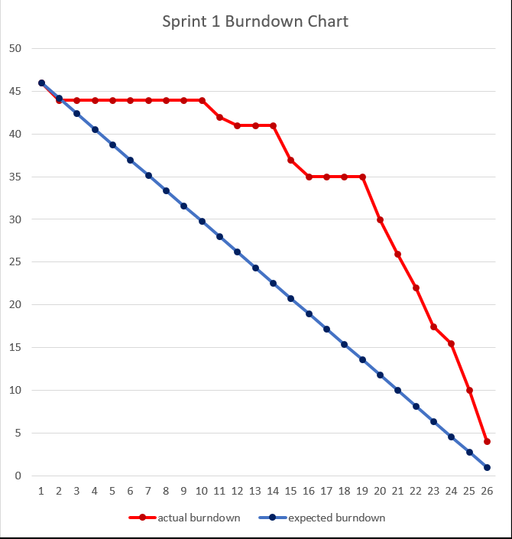*Figure 1 - Sprint 1 Burndown Chart*

Productivity started slow, but picked up in the latter weeks of the sprint. Group 114 kept a stable demeanour, avoiding conflict during the working period. The first iteration of the CityFinder Django framework was established early [day 1-2] by team member Sean Li, and developed upon later [days 19-26] by the rest of the team.

One of the first major signs of group norming occurred during the second week of the sprint, when the team compiled a full diagrammatical writeup justifying CityFinder’s high-level architecture [days 4-9]. This task concreted the team dynamic, and allowed a rise in productivity.

**What you did not do well?**

CS students yielded a variety of troubleshooting errors when developing CityFinder, with the main cause being Week 9’s database implementation. Due to the Django framework defaulting to sqlite3, a valid MySQL schema had not been implemented until the last minute of the sprint [days 23-24]. Team member Zaine Ashe spent approx. 3 hours troubleshooting the issue, which pushed development back significantly. Time management issues such as these could have been mitigated through SCRUM micro-management.

There was also a stagnation in group productivity during the second last week of the sprint [days 14-19]. A fundamental miscommunication error led to members designing UI pages independently of each other. This was detrimental to productivity, as the designs had no shared aesthetic and did not qualify as their own artefacts. This miscommunication wasn’t remedied until the team contacted their assigned tutor. By then, approximately 4 days of productivity had been wasted.

**What will you do differently next time to improve the performance of the team?**

Group 114 agreed to shuffle the role of SCRUM master with each week. This was intended to provide a balanced group dynamic and allow each member to play the role of leader. Considering the mistakes made in Sprint 1, it is evident that the team needs a new SCRUM approach. The most prominent cause of frustration during this sprint was poor team management. Each member of group 114 has the capacity perform extremely well under the right circumstances, but poor management prevents this. To yield better results from sprint 2, the team will need to elect a dedicated SCRUM master, rather than switching the role weekly.

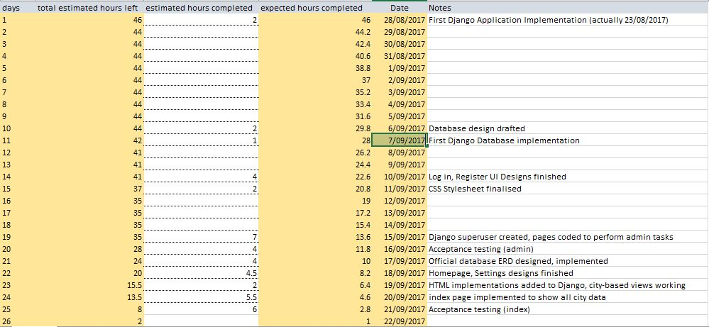*Figure 2 – Sprint 1 Burndown by day*